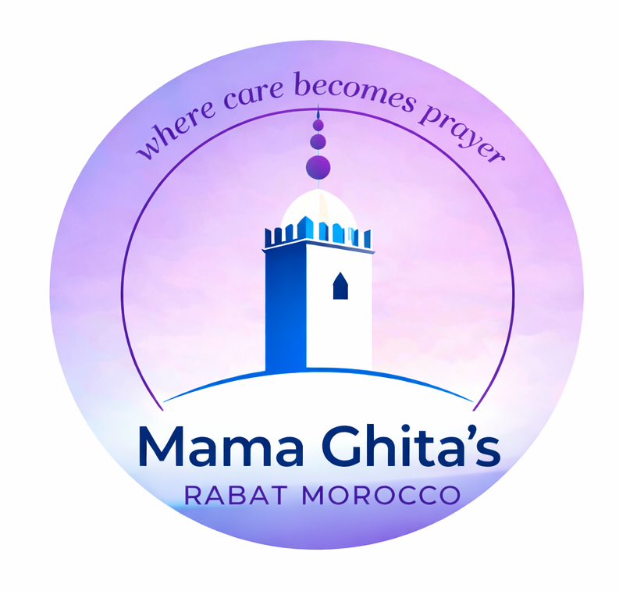
Pilgrimage of the Poor
Rabat, Morocco - May 2026
Booking Form
Full name | Email address
Mobile number including country code | Emergency contact name
Country of residence | Emergency contact phone number
Dietary needs or allergies | Anything else you would like us to know ahead of your arrival
The booking form is completed with a $1000 deposit.
The remaining balance of $2200 due by 20th April 2026.
Please select one of the payment options below
Wise Bank Transfer Click HERE Venmo Click HERE
Further practical information will follow closer to the time. You’ll also be warmly invited to join the Pilgrimage of the Poor in Morocco WhatsApp group.
With gentleness,
Younesse
Mama Ghita’s salam@mamaghitas.com

